

Pottery Wheel TY001

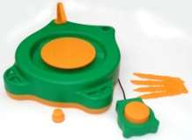

The children's pottery wheel is our newly developed next-generation pottery machine, characterized by its economical safety, attractive appearance, compact size, low noise, powerful performance, portability, and environmental friendliness. It is powered by a 12V DC power supply and features a foot pedal switch, along with a small package of clay, paints, and brushes. It is the ideal tool for learning and creating pottery.

\*\*Product Description:\*\*

The package includes: a turntable, foot pedal, 4 shaping tools, 6 non-toxic paints, 2 packs of air-dry clay, a waterproof cap, 2 paintbrushes, a color palette, and an instruction manual.

\*\*Technical Parameters:\*\*

- Maximum Output Power: 4W

- Rated Input Voltage: 6V

- Transmission Mechanism: Turbine Worm Gear

- Turntable Speed: 60-80 RPM

- Turntable Size: 130mm

- Packaging Size: 285mm x 340mm x 85mm

- Net Weight: 1.4kg