Professional kit (W600MA)
8 in ONE

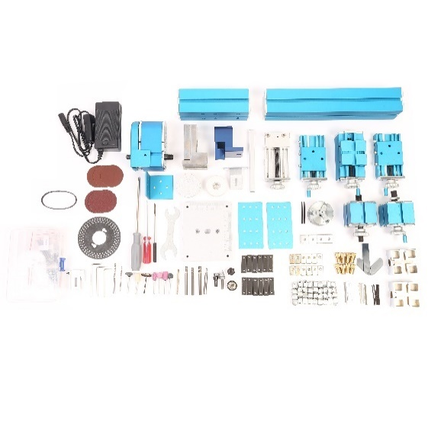 | 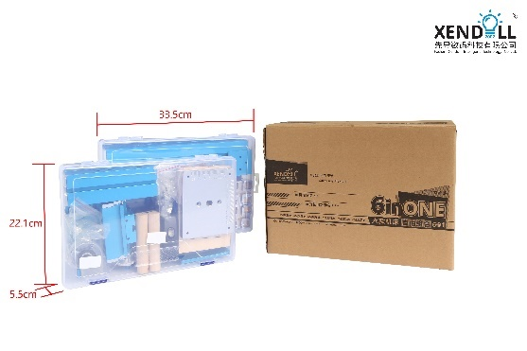
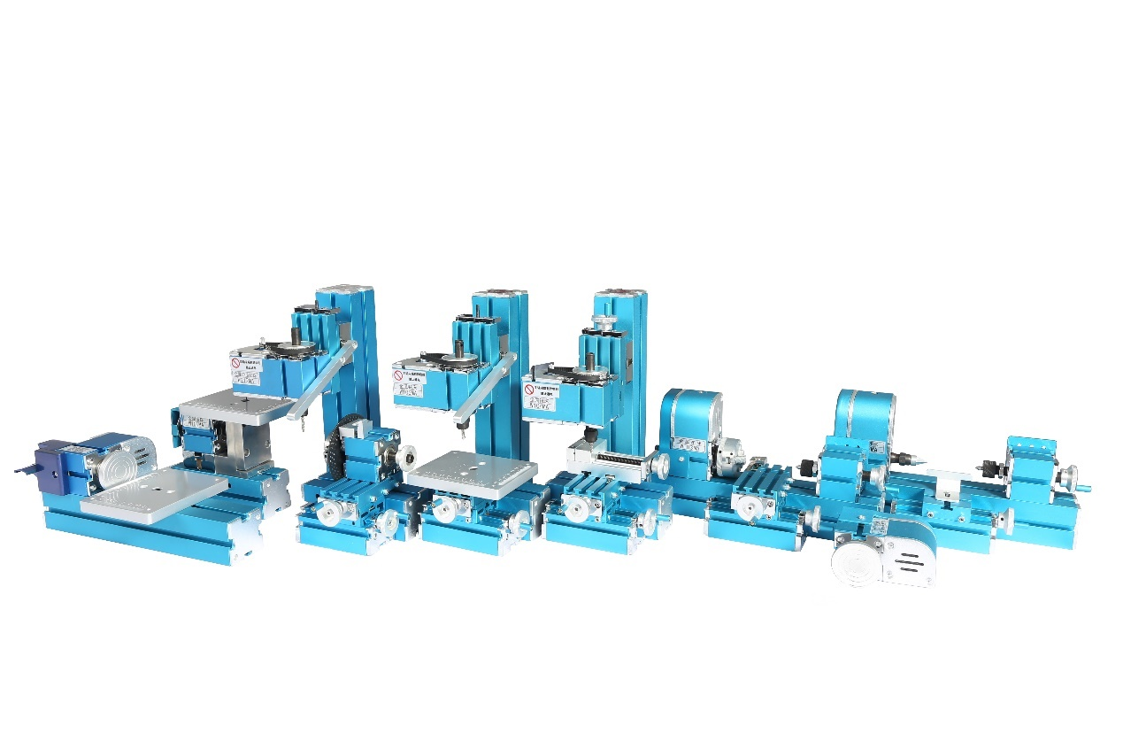

Applications:
Youth Activity Center, School General Technical Room, Science and Technology Activity Room Equipment, Science and Technology Museum Student Science and Technology Creation, DIY hobbyist.

This Professional kit can be assembled into jigsaw, lathe, woodturning lathe, drilling machine, milling machine, sanding machine, grinding machine, Copying Attachment Woodturning Lathe etc, and realize at least 8 functions of those machines. it is only assembled in three of 7 kind machines and on-hand grinding machine at the same time, for there are only ONE motor and headstock are offered.. In addition to some accessories, the kit can be assemble into specialist machines.

Description:
XENDOLL power tools: It is driven by 12V safe direct current transformer. It is helpful for improving manual ability and independent thinking, thus effectively improving intelligence of children. So as to be a good didactical tool for children. It is also an ideal tool for DIY hobbyist and modelmaker to make various craft. Wear goggles when using. Children need to be guided by adults.

Parameter:
Input voltage: AC100V~240V 50/60HZ
Output voltage : DC12V 2A
Motor rated power: 24W
Motor speed: High speed motor 20000r/min±15%
Spindle speed: high speed motor 3000r/min±15%
Spindle jump: <0.1mm
Handle scale: 0.1mm/division
Packing size:
Weight:

Jigsaw machine:
Jigsaw blade:4mm
Working table: 100*120mm

On-hand grinding machine:
Rotary table:49mm

Woodturning machine:
Center height: 25mm
Center distance: 110mm
Swing over bed: 50mm

Lather machine:
Center height: 25mm
Center distance: 110mm
Swing over bed: 50mm
Maximum processing diameter: 13mm positive claw, 45mm reverse claw
Three-jaw chuck clamping diameter: 13mm claw, 45mm reverse claw

Milling machine:
Long slider stroke: 45mm
Short slider stroke: 35mm
Collet set (6-piece): Φ1/Φ2/ Φ2.5/Φ3/Φ3.5/Φ4/Φ5/Φ6
Milling cutter: Φ2/Φ3/Φ5/Φ6

Drilling machine:
Long slider stroke: 45mm
Short slider stroke: 35mm
Collet set (6-piece): Φ1/Φ2/ Φ2.5/Φ3/Φ3.5/Φ4/Φ5/Φ6
Twist cutter: Φ2/Φ3

Sanding machine:
Center height: 25mm
Rotary table:49mm

Drilling machine with dividing attachment:
Long slider stroke: 45mm
Short slider stroke: 35mm
Chuck diameter:48mm
Three-jaw chuck clamping diameter: 13mm claw, 45mm reverse claw
Collet set (6-piece): Φ1/Φ2/ Φ2.5/Φ3/Φ3.5/Φ4/Φ5/Φ6
Milling cutter: Φ2/Φ3/Φ5/Φ6
Outer Diameter: 88mm
Inner Diameter: 26mm
Dial parameters:36,40,48 holes respectively

Processing ability: It can process wood, plastic and soft metals (pure copper and pure aluminum).

