Mini Metal machine - Classic kit (W400MA)
6 in ONE
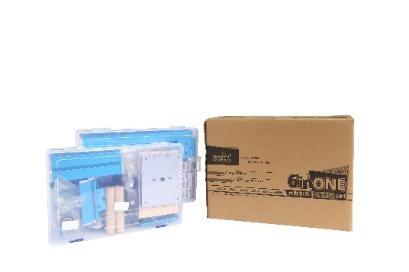 | 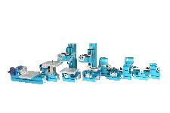
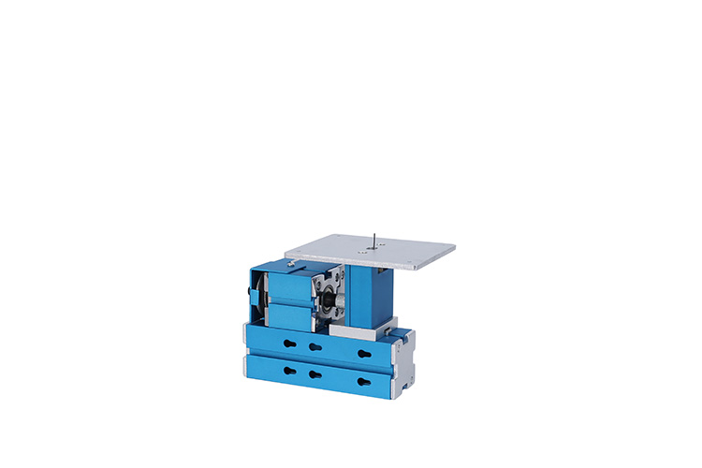  Mini metal jigsaw machine | 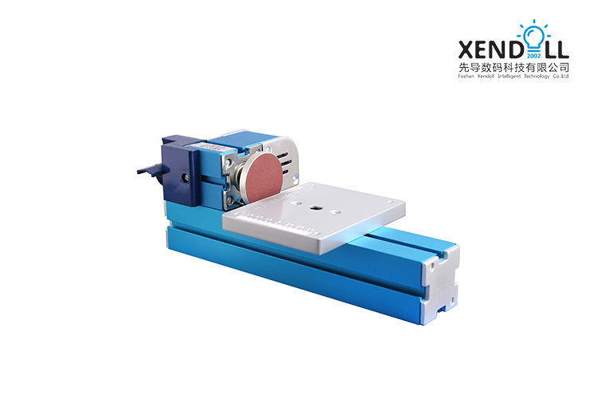  Mini metal Sanding machine
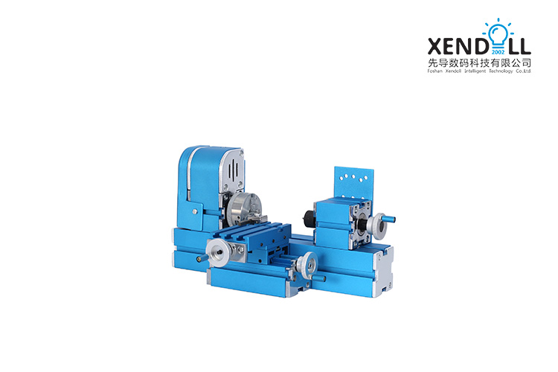  Mini metal lathe machine | 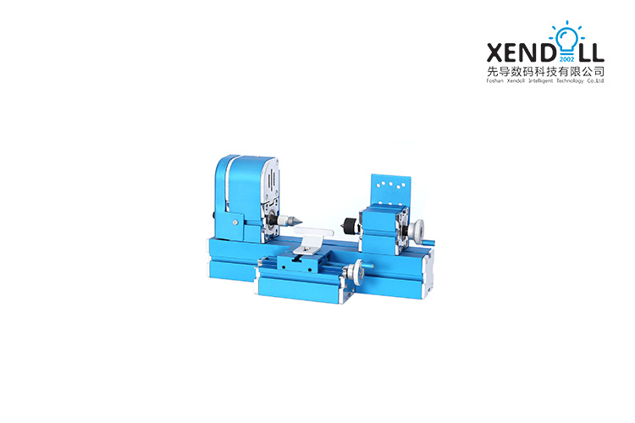  Mini metal wood turning machine
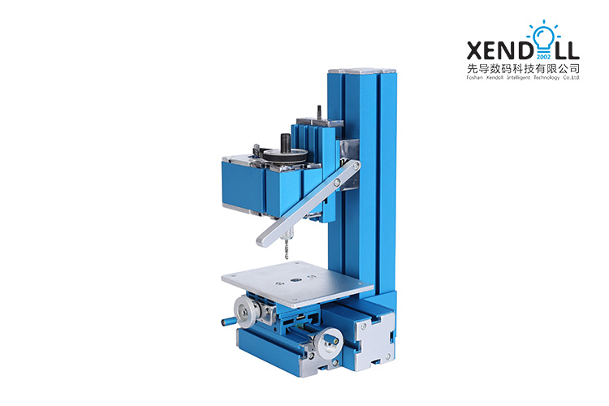  Mini metal Drilling machine | 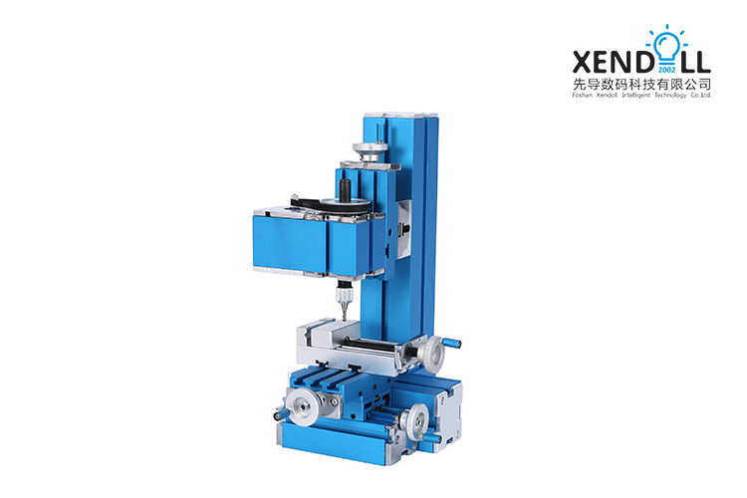  Mini metal Milling machine
Applications:
Youth Activity Center, School General Technical Room, Science and Technology Activity Room Equipment, Science and Technology Museum Student Science and Technology Creation, DIY hobbyist.

This classic kit can be assembled into jigsaw, lathe, woodturning lathe, drilling machine, milling machine, sanding machine. And realize the functions of those machines. But it is only assembled in one of 6 kind machines at the same time; for there are only ONE motor and headstock are offered.

All the parts and accessories are stored in two containers, which save your space get more value. Enjoy your DIY moment.

Description:
XENDOLL power tools: It is driven by 12V safe direct current transformer. It is helpful for improving manual ability and independent thinking, thus effectively improving intelligence of children. So as to be a good didactical tool for children. It is also an ideal tool for DIY hobbyist and modelmaker to make various craft. Wear goggles when using. Children need to be guided by adults.

Parameter:
Input voltage: AC100V~240V 50/60HZ
Output voltage : DC12V 2A
Motor rated power: 24W
Motor speed: High speed motor 20000r/min±15%
Spindle speed: high speed motor 3000r/min±15%
Spindle jump: <0.1mm
Handle scale: 0.1mm/division
Packing size: 340*180*240mm
Weight: 4.59/5kg

Jigsaw machine:
Jigsaw blade:4mm
Working table: 100*120mm
Size: 148x50x124mm

Woodturning machine:
Center height: 25mm
Center distance: 110mm
Swing over bed: 50mm
Size:278*100*124mm

Milling machine:
Long slider stroke: 45mm
Short slider stroke: 35mm
Collet set (6-piece): Φ1/Φ2/ Φ2.5/Φ3/Φ3.5/Φ4/Φ5/Φ6
Milling cutter: Φ2/Φ3/Φ5/Φ6
Size: 278x100x150mm

Drilling machine:
Long slider stroke: 45mm
Short slider stroke: 35mm
Collet set (6-piece): Φ1、Φ2、Φ2.5、Φ3、Φ3.5、Φ4、Φ5、Φ6
Twist cutter: Φ2、Φ3
Size: 148x150x278mm

Sanding machine:
Center height: 25mm
Rotary table:49mm
Size: 148x150x278mm

Lathe Machine
Center height: 25mm
Center distance: 110mm
Swing over bed: 50mm
Maximum processing diameter: 13mm positive claw, 45mm reverse claw
Three-jaw chuck clamping diameter: 13mm claw, 45mm reverse claw
Size: 278x100x150mm

Processing ability: It can process wood, plastic and soft metals (pure copper and pure aluminum).

