Basic Kit
Three in one

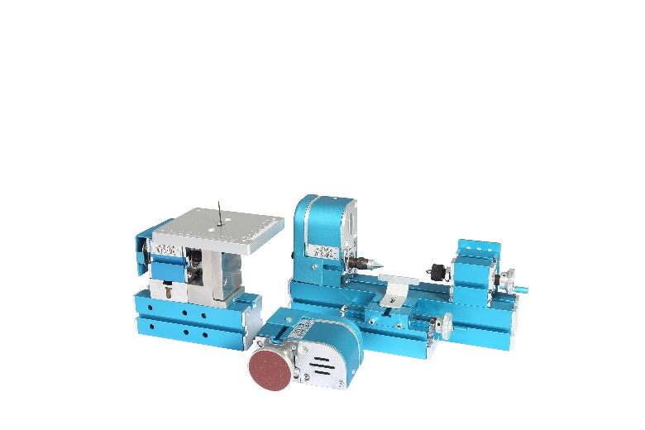 | 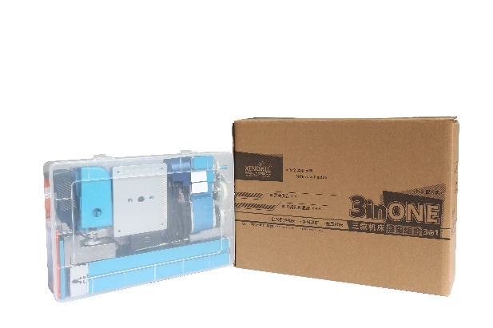

Applications:
Youth Activity Center, School General Technical Room, Science and Technology Activity Room Equipment, Science and Technology Museum Student Science and Technology Creation, DIY hobbyist.

This basic kit can be assembled into jigsaw, woodturning lathe, on-hand grinding machine, and realize the functions of those machines. But it is only assembled in one of 3 kind machines at the same time; for there are only ONE motor and headstock offered.

Description:
XENDOLL power tools: It is driven by 12V safe direct current transformer. It is helpful for improving manual ability and independent thinking, thus effectively improving intelligence of children. So as to be a good didactical tool for children. It is also an ideal tool for DIY hobbyist and modelmaker to make various craft. Wear goggles when using. Children need to be guided by adults.

Parameter:
Input voltage: AC100V~240V 50/60HZ
Output voltage : DC12V 2A
Motor rated power: 24W
Motor speed: High speed motor 20000r/min±15%
Spindle speed: high speed motor 3000r/min±15%
Spindle jump: <0.1mm
Handle scale: 0.1mm/division
Packing size: 395*105*280mm
Weight: 2.97/3.37kg

Jigsaw machine:
Jigsaw blade:4mm
Working table: 100*120mm

On-hand grinding machine:
Rotary table:49mm

Woodturning machine:
Center height: 25mm
Center distance: 110mm
Swing over bed: 50mm

Processing ability: It can process wood, plastic and soft metals (pure copper and pure aluminum).

